A Project Report on

Digital Store

By

**Tushar Rajendra Jagtap**

MCA – II

2020-2021

University Roll No: 20097

To

Savitribai Phule Pune University

Pune- 411041

In Partial Fulfillment of the Degree of

Master in Computer Application (M. C. A.)

Under The Guidance Of

**Prof. Dr. Ramesh Jadhav**



Sinhgad Technical Education Society’s

SINHGAD INSTITUTE OF MANAGEMENT,

Vadgaon Bk, Pune

(Affiliated to Savitribai Phule Pune University, Approved by AICTE

& Accredited by National Board of Accreditation, New Delhi)

**Index**

|  |  |
| --- | --- |
| **Chapter** | **Page number** |
| **CHAPTER 1 : INTRODUCTION** | |
| 1.1 Existing System | **3** |
| 1.2 Need for System | **3** |
| 1.3 Operating Environment Hardware and Software | **4** |
| **CHAPTER 2 : PROPOSED SYSTEM** | |
| 2.1 Proposed System (Introduction of system) | **5** |
| 2.2 Module specifications (Scope) | **5** |
| 2.3 Objectives of System | **6** |
| **CHAPTER 3 : ANALYSIS & DESIGN** | |
| 3.1 Use Case Diagrams | **7** |
| 3.2 Activity Diagram | **8** |
| 3.3 Class Diagram | **10** |
| 3.4 Module Hierarchy Diagram | **11** |
| 3.5 Table specifications (Database design) | **12** |
| **CHAPTER 4 : USER MANUAL** | |
| 4.1 User Interface Screens (Input) | **13** |
| 4.2 Output Screens with data | **13** |
| 4.3 Sample program code | **21** |
| 4.4 Limitations and Bibliography | **24** |

**CHAPTER 1: INTRODUCTION**

* 1. Existing System :-

In the present scenario no dedicated website for purchasing all type of downloadable product likes Amazon, different product have different website like purchasing image purchases from pixabay and download video have different websites

This method time consuming because go different-different website for purchasing downloadable product.

Also from the owner’s point of view maintaining data very hard because he/she sell his/her product in different-different website. If any website have loopholes that time his/her product in risk.

1.2 Need for System:

Using these website customers purchases downloadable products like image, video, songs, software’s, data files and many more without going different-different website, This Website Helps both Customers and Owner

This method time consuming because go different-different website for purchasing downloadable product.

There are so may discount so that customers will get best and original product in low price

By using this website owner will also track which product is famous and how much money earned and it also reduce maintenance cost.

1.3 Operating Environment Hardware and Software:

Hardware/Software Interface:

This section lists the minimum hardware and software requirements needed to run the system efficiently.

Hardware Interface:

• Pentium Processor

• 60 MB of free hard-drive space

• 128 MB of RAM

Software Interface:

• Operating System: Windows (Vista/7 or above)

• Web Browser: IE 10 or above, Mozilla FF 31 and above or Google Chrome

• Python, Django

**CHAPTER 2 : PROPOSED SYSTEM**

2.1 Proposed System (Introduction of system):

The Digital Store can be defined as a simple and convenient way for customers to purchase Downloadable produces, without going different – deferent websites.

This system is enabled by the internet – using this web application Customer can download all types of downloadable products.

As per this system, customer visits the Digital store website, browses the various types of product, and purchases product for all type of use.

After Complete Payment, Customer can download product any time and use anywhere without copyright issue.

Payments for such online product can be made through debit cards, credit cards and net banking.

This system is completely safe and secure for purchasing downloadable product.

2.2 Module specifications (Scope):

Scope:

Digital Store Website can sale downloadable product For Customer’s, through only one platform. It provides you with a convenient way to sale your Products on Website.

This Website make easy for user to buy all types of product from one website with easy steps can get original product.

Modules

1. Admin Module:

* Complete access to the website.
* Can add, Remove, Update Items.
* Check and Remove Users.
* Check which user perches which product.
* Add category

1. User:

* Limited Access to the website.
* Can register and Login.
* View Products.
* Online Payment.
* Download products after payment.

2.3 Objectives of System:

The main purpose of a Digital Store is provide convenient way to customers for purchasing downloadable product for personal or professional use.

The main reason is that it benefits both the customer and the business.

With a website, customers can easily browse all the products the Store has available; completing payment customer can download any time of his product.

From the Store/owner perspective, they no longer spend time on upload product in different-different website; stop worrying about Website Security errors.

**CHAPTER 3 : ANALYSIS & DESIGN**

3.1 Use Case Diagrams

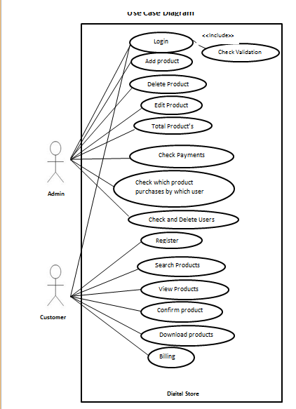

3.2 Activity Diagram

Customer

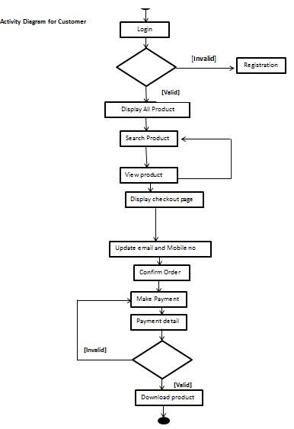

Admin

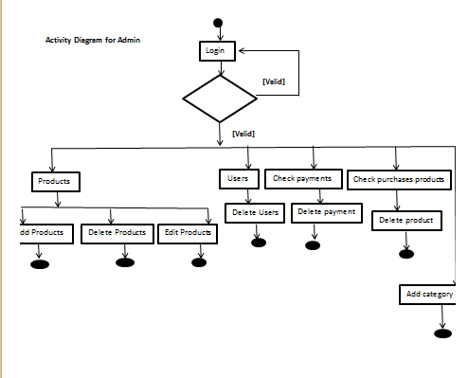

3.3 Class Diagram

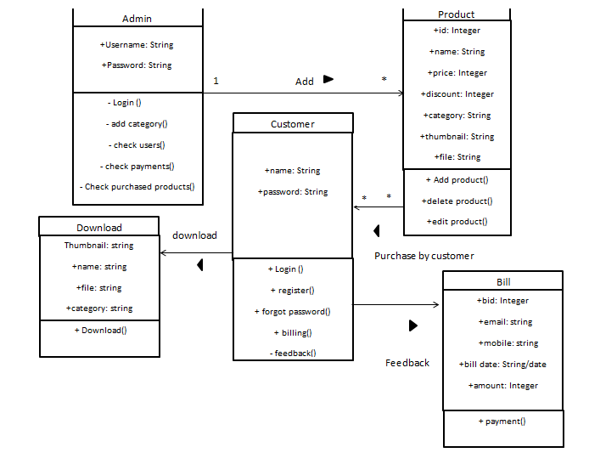

3.4 Module Hierarchy Diagram

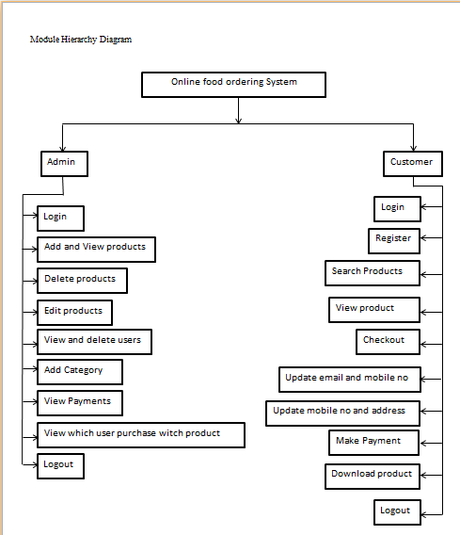

3.5 Table specifications (Database design)

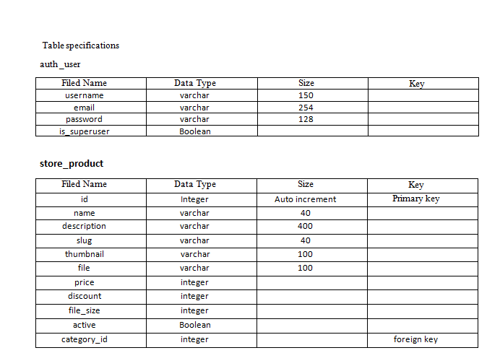

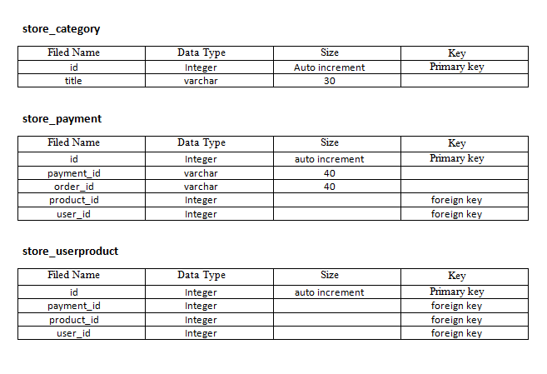

4.1 User Interface Screens (Input)

and

4.2 Output Screens with data

Admin Side

Admin Login

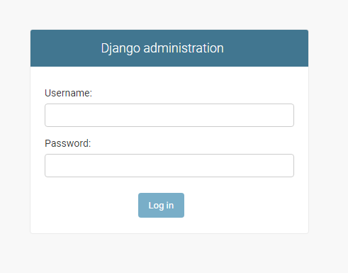

Admin Dashboard

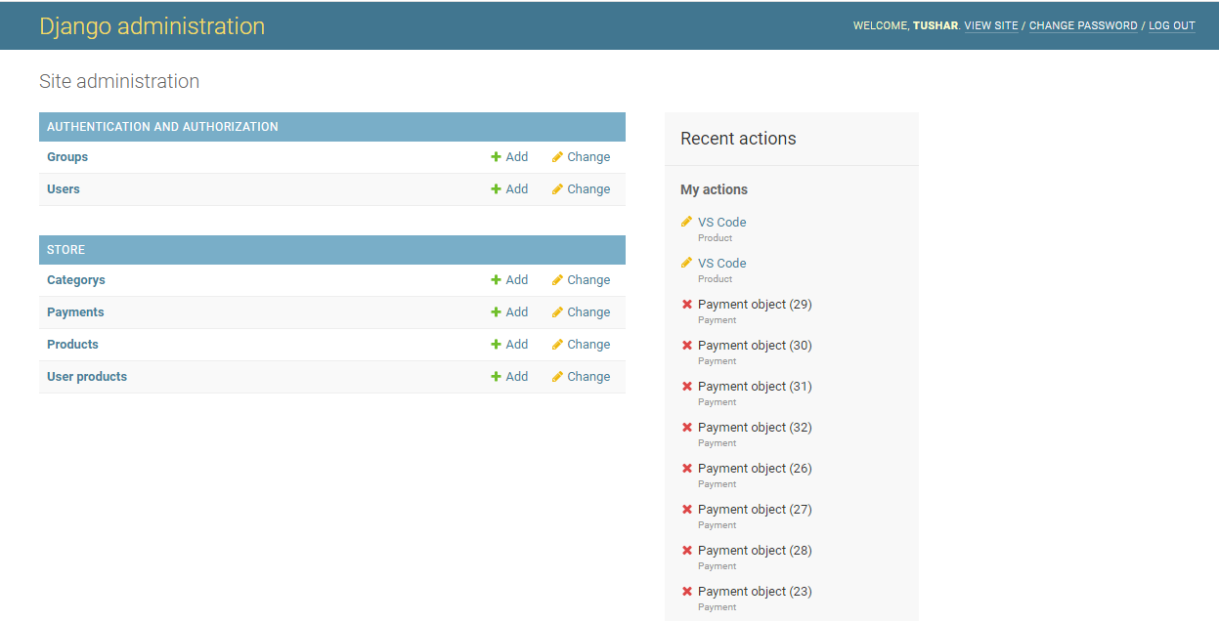

Users

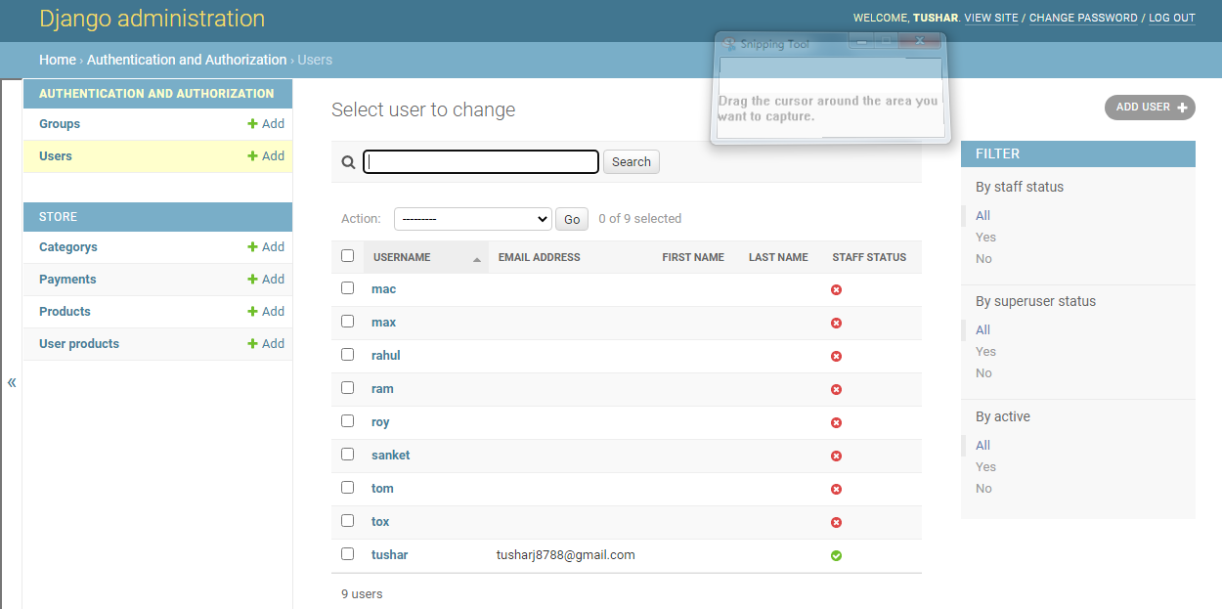

Category

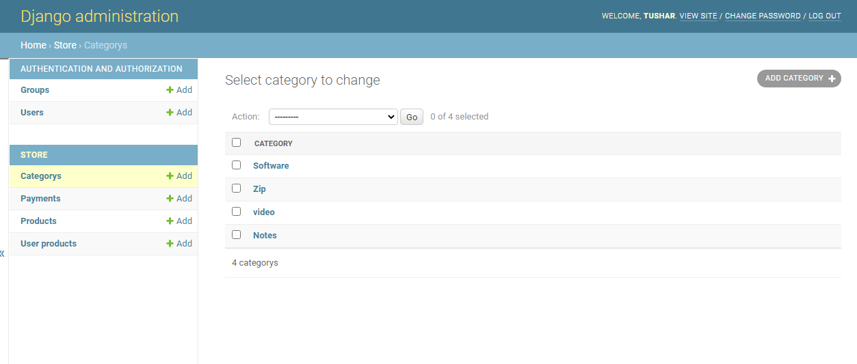

Product

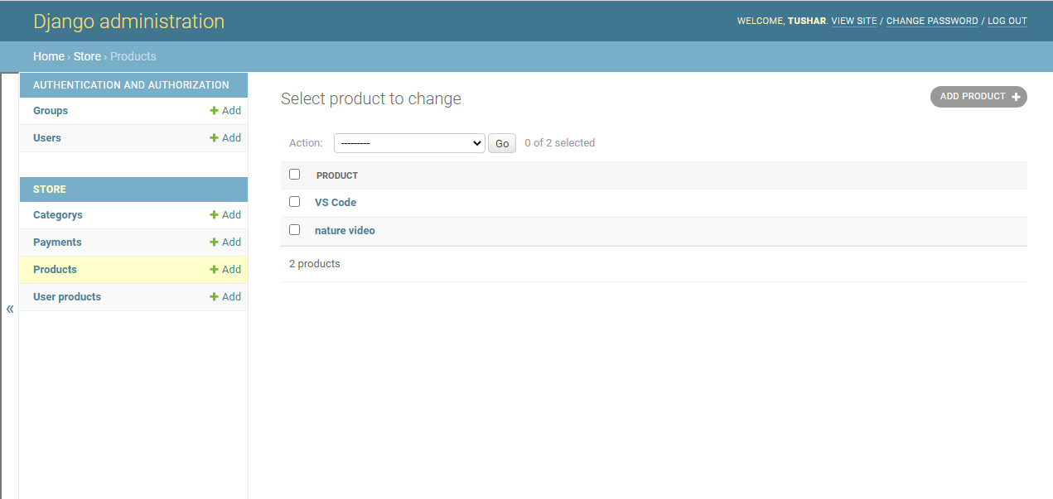

Payment

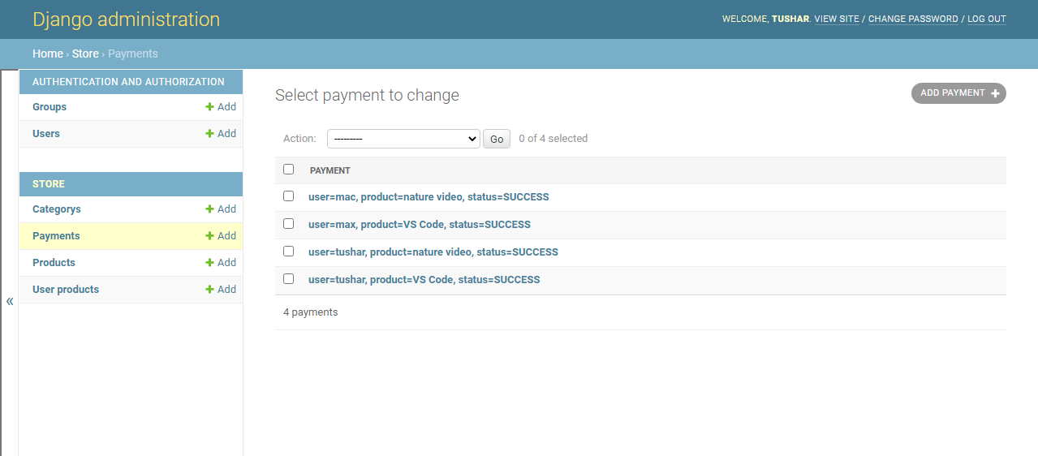

user purchases products

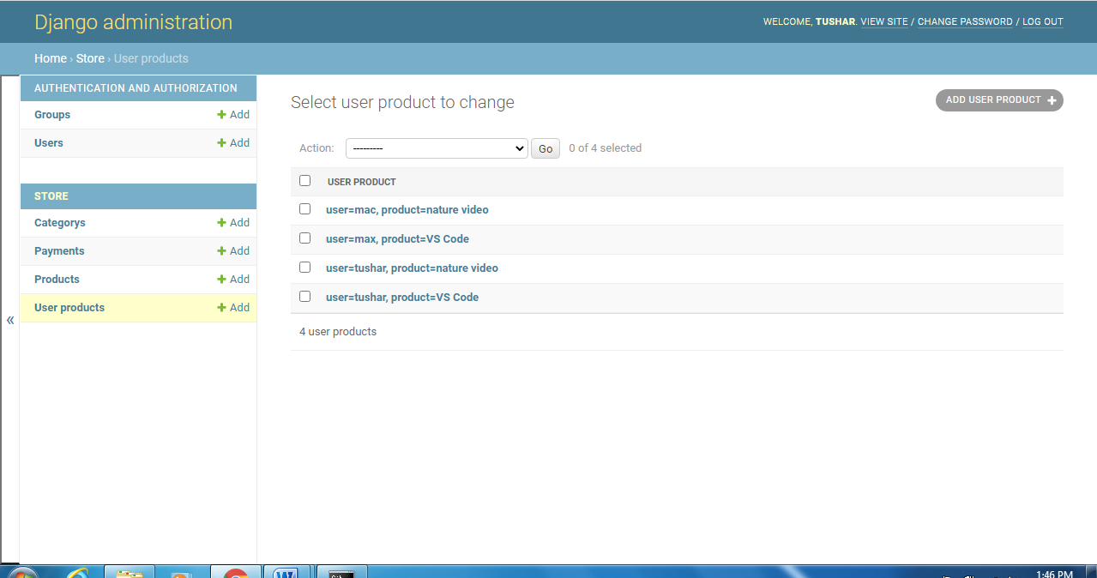

User Side

Homepage

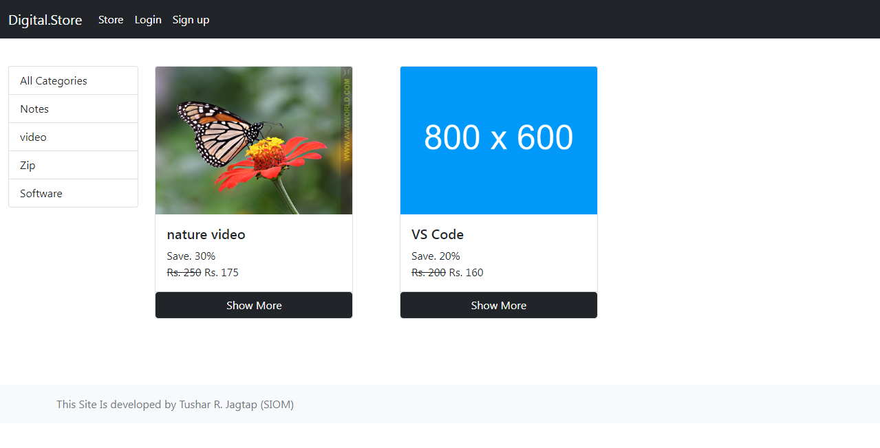

Login Page

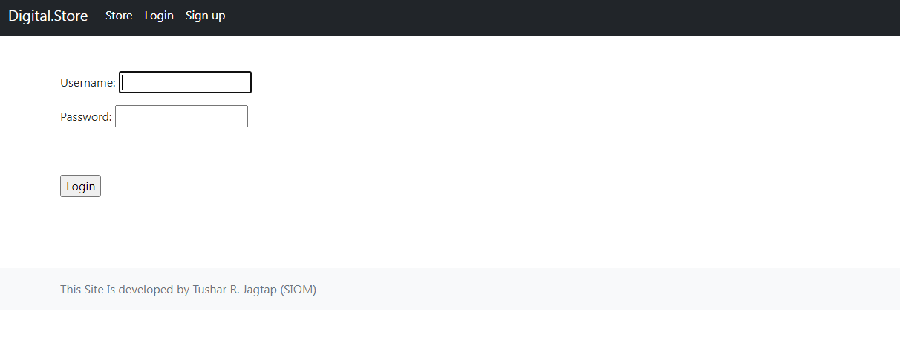

Signup page

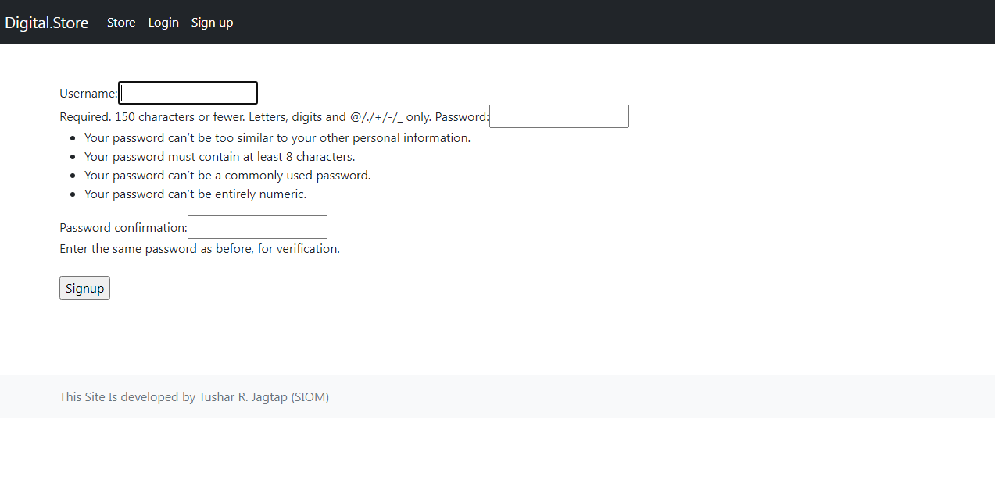

Dashboard

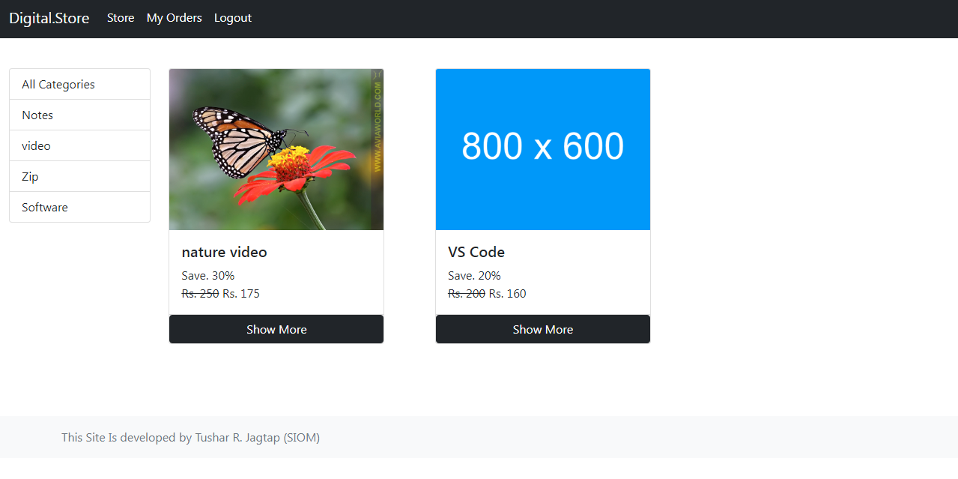

View product

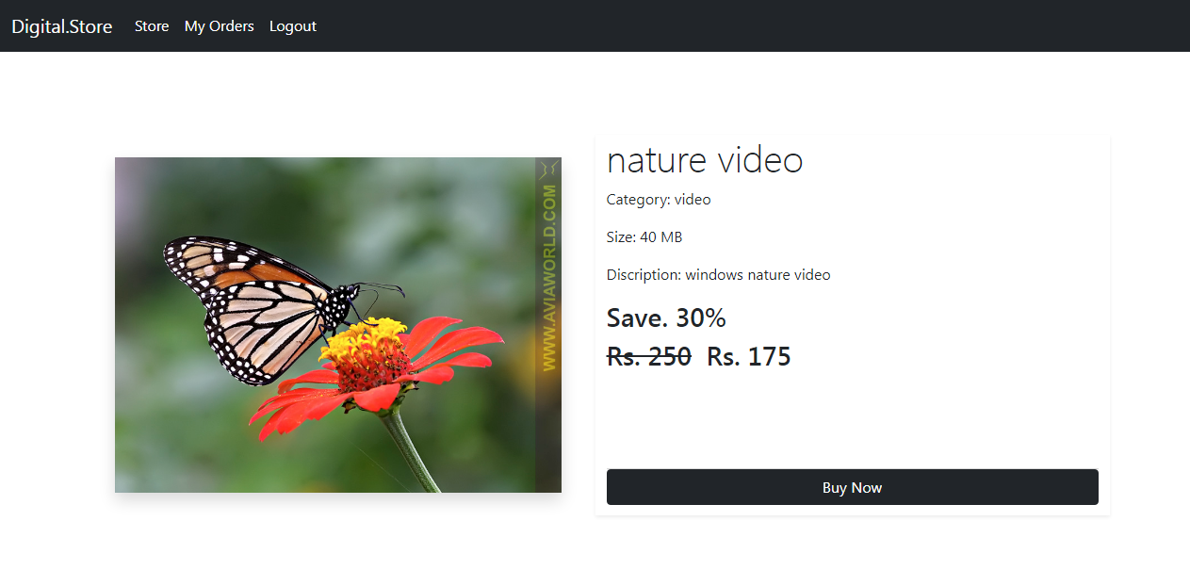

Checkout page

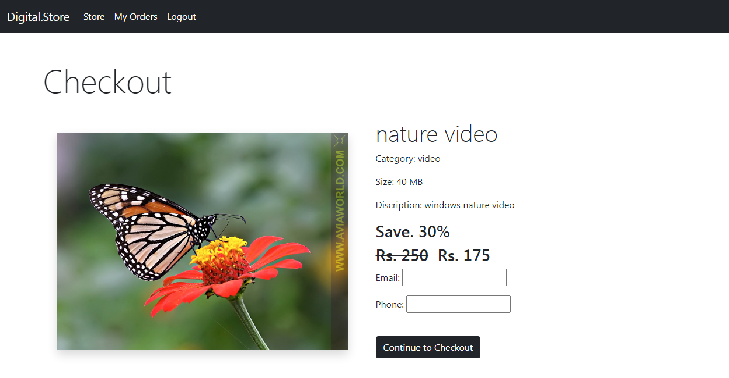

Payment

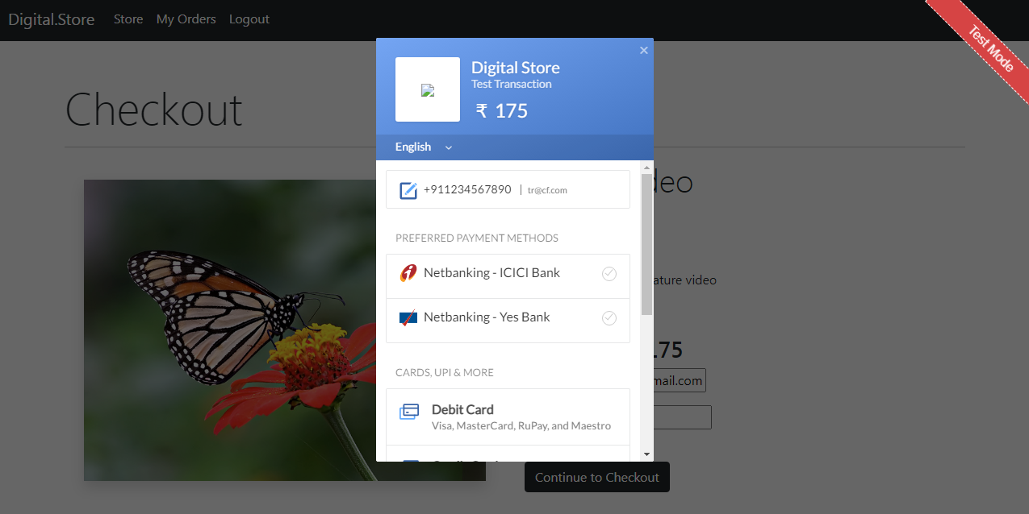

My order page

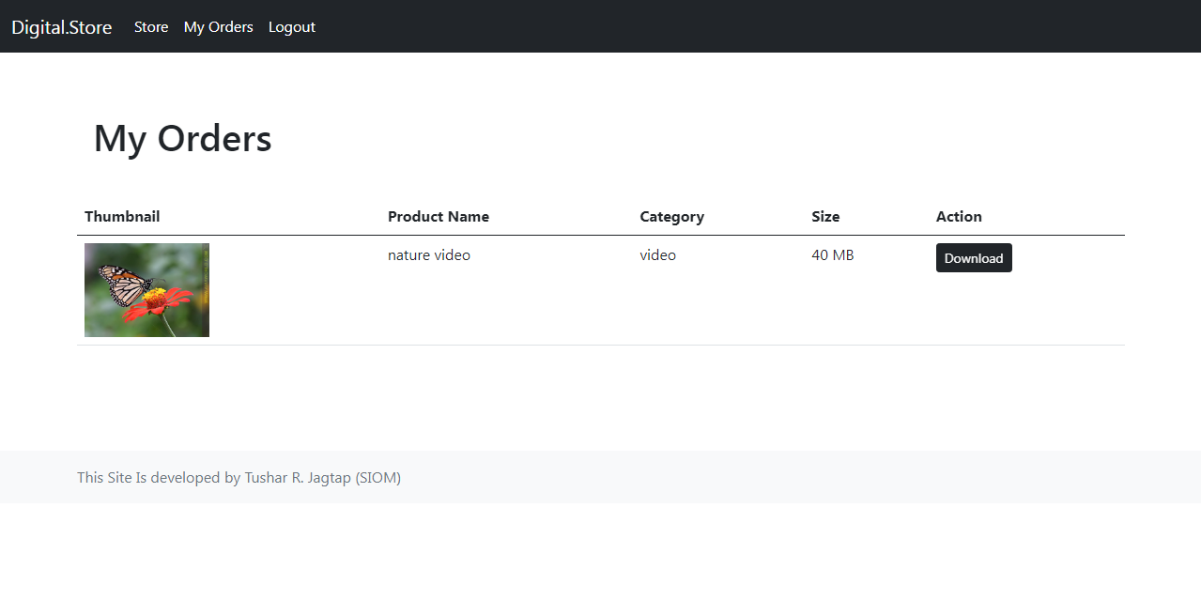

**4.3 Sample program code**

User Dashboard

base.html

<!DOCTYPE html>

<html lang="en">

<head>

  <meta charset="UTF-8">

  <link href="https://cdn.jsdelivr.net/npm/bootstrap@5.0.2/dist/css/bootstrap.min.css" rel="stylesheet"

    integrity="sha384-EVSTQN3/azprG1Anm3QDgpJLIm9Nao0Yz1ztcQTwFspd3yD65VohhpuuCOmLASjC" crossorigin="anonymous">

  <meta http-equiv="X-UA-Compatible" content="IE=edge">

  <script src="https://cdn.jsdelivr.net/npm/bootstrap@5.0.2/dist/js/bootstrap.bundle.min.js"

    integrity="sha384-MrcW6ZMFYlzcLA8Nl+NtUVF0sA7MsXsP1UyJoMp4YLEuNSfAP+JcXn/tWtIaxVXM"

    crossorigin="anonymous"></script>

  <meta name="viewport" content="width=device-width, initial-scale=1.0">

  <title>Digital Store</title>

  <style>

    .display-5 {

      font-size: 40px;

      font-weight: 400px;

    }

  </style>

</head>

<body>

  <nav class="navbar navbar-expand-lg navbar-dark bg-dark">

    <div class="container-fluid">

      <a class="navbar-brand" href="/">Digital.Store</a>

      <button class="navbar-toggler" type="button" data-bs-toggle="collapse" data-bs-target="#navbarScroll"

        aria-controls="navbarScroll" aria-expanded="false" aria-label="Toggle navigation">

        <span class="navbar-toggler-icon"></span>

      </button>

      <div class="collapse navbar-collapse" id="navbarScroll">

        <ul class="navbar-nav my-lg-0 navbar-nav-scroll" style="--bs-scroll-height: 100px;">

          <li class="nav-item">

            <a class="nav-link active" aria-current="page" href="/">Store</a>

          </li>

        </ul>

        {% if request.user.is_authenticated %}

        <ul class="navbar-nav my-lg-0 navbar-nav-scroll" style="--bs-scroll-height: 100px;">

          <li class="nav-item">

            <a class="nav-link active" aria-current="page" href="/orders">My Orders</a>

          </li>

          <li class="nav-item">

            <a class="nav-link active" aria-current="page" href="/logout">Logout</a>

          </li>

        </ul>

        {% else %}

        <ul class="navbar-nav  my-lg-0 navbar-nav-scroll" style="--bs-scroll-height: 100px;">

          <li class="nav-item">

            <a class="nav-link active" aria-current="page" href="/login">Login</a>

          </li>

          <li class="nav-item">

            <a class="nav-link active" aria-current="page" href="/signup">Sign up</a>

          </li>

        </ul>

        {%endif%}

      </div>

    </div>

  </nav>

  <div>

    {% block content %}

    {% endblock %}

  </div>

  <br>

  <br>

  <br>

  <br>

  <footer class="footer mt-auto py-3 bg-light">

    <div class="container">

      <span class="text-muted">This Site Is developed by Tushar R. Jagtap (SIOM)</span>

    </div>

  </footer>

</body>

</html>

index.html

{% extends 'store/base.html' %}

{% block content %}

<!-- {{categories}} -->

{% load store_tags %}

<br>

<div class="container-fluid">

    <div class="row mt-3">

        <div id="catogary" class="col-2">

            <div class="list-group">

                <a class="list-group-item list-group-item-action" href="/">All Categories</a>

                {% for category in categories%}

                <a class="list-group-item list-group-item-action"

                    href="?category={{category.pk}}">{{category.title}}</a>

                {% endfor %}

            </div>

        </div>

        <div id='product' class="col">

            <div class="row">

                {% for product in products %}

                <div class="col-4">

                    <div class="card" style="width: 18rem;">

                        <img src="{{product.thumbnail.url}}" class="card-img-top" alt="...">

                        <div class="card-body">

                            <h5 class="card-title">{{product.name}}</h5>

                            <p class="card-text">Save. {{product.discount}}% <br>

                                <span><del>Rs. {{product.price}}</del></span>

                                Rs. {%sale_price product.price product.discount%}

                            </p>

                        </div>

                        <div class="card-footer d-grid p-0">

                            <a href="/product/{{product.slug}}" class="btn btn-dark btn-block m-0">Show More</a>

                        </div>

                    </div>

                </div>

                {% endfor %}

            </div>

        </div>

    </div>

</div>

{% endblock %}

4.3 Limitations and Bibliography

Bibliography

* <https://www.w3schools.com/>
* <https://www.feelfreetocode.com/>
* <https://www.javatpoint.com/>
* <https://www.geeksforgeeks.org/>

Limitations

* This web app for only one admin can upload product
* Payment in Dummy mode only